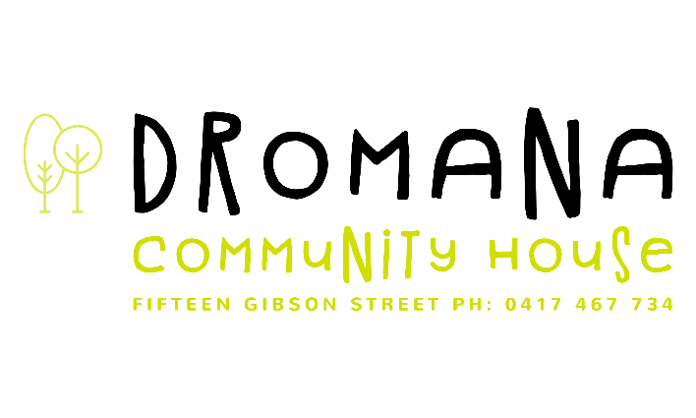
Terms and Conditions of Enrolment and Attendance
I/We:
- Have read the Terms and Conditions of Enrolment and Attendance.
- Understand that the person/s nominated as Primary Contact are the authorised parties to enrol, cancel enrolment, release, and authorise release of the child
- Read the Parent Handbook and understand any changes will be emailed and displayed.
- Agree to comply with all Government requirements in relation to the service.
- Understand that children who are third priority under the Priority of Access Guidelines may require you to alter days or give up their place at the Service to provide a place for a higher priority child.
- ‘No jab, no play’ policy
In keeping with the Federal and State Governments’ ‘NO jab, no play’ policies, children MUST have acceptable proof of immunisation prior to enrolment in the form of an Immunisation History Statement from Medicare, we are not legally able to accept any other form of proof of immunisation.
- Agree that in the case of illness, accident or injury, the Service will attempt to contact me/us and where I/we cannot be contacted medical care and/or ambulance services may be sought and given to the child, and I/we agree to meet any cost incurred.
- Are aware that children will be excluded from the Service if they have contracted a contagious disease or condition or are unwell. Children’s services have a responsibility under the Public Health and Wellbeing Regulations 2019 to help manage infectious diseases in their facilities. Different exclusion periods apply to different infectious diseases for cases and contacts. See the list displayed
- Understand that children will be accepted back into the Service on provision of a ‘clearance certificate’ from a medical practitioner if applicable.
- Agree to provide the Service with all information regarding the health of my/our child
- The presentation of a medical certificate in the event of the child developing a medical disability and or a Medical Plan may be required.
- Understand that the Service may be used as a training and observation centre by students aiming to/or already working with young children
- Are aware that the Service may occasionally have visitors, or volunteers at the Centre, and consent to my/our child being in the presence of volunteers or visitors, with appropriate supervision.
- Agree to pay the fortnightly fee on the due date through EziDebit
- Agree that we are required to give notice in writing two weeks prior to the date of withdrawal; otherwise, fees will continue to be charged. During this period, we are aware that if our child does not attend, we are liable to pay full fees
- Are aware that fees for public holidays are not payable if the day is a usual day of attendance
- Are aware that fees are payable for all booked days, including absent days, i.e., sick days, and family holidays.
- Are aware that it is our responsibility to maintain a current Family Assistance Office Income Assessment Notice for Child Care Benefit purposes
- Are aware that to have access to Child Care Benefit we need to meet all current Child Care Benefit requirements
- Understand that a system of payment for late collection operates at the Service, to cover payments to staff, and that I/we are obliged to drop off/pick up the child as negotiated with the Service. Any late collection will result in a fee being charged
- Understand that should this account be referred to a Debt Collection Agency an additional fee of 15% of the outstanding amount will be incurred
- Statements will be sent out fortnightly, you may prepay for the term, but we expect at least two weeks in advance is paid.
- The Service is closed on days of CODE RED
- Entry and Exit conditions apply and the Educators will send you the details.
- A strict cleaning and hygiene routine is undertaken throughout the sessions, please always observe social distancing
- In dealing with a Concern or Complaint, please speak directly to the Team Leader or the Manager. Writing your complaint down can clarify your concerns and bring all your information together. It also means you’ll have a clear record of your complaint. Little Gum are required to notify the department in the same situations and timelines, and complete the Notification of serious incidents (including physical or sexual abuse) complaints, and additional children attending service in an emergency form
If you are not satisfied with the action taken by the Service, please contact

The Authorised Officer Phone Southern Metropo​​litan Area
(03) 8904 2500
email: smr.qar@education.vic.gov.au
I/We have read, understood, and agree to abide by the conditions of this contract.
Primary Parent / Guardian
Print Name: ___________________
Signature _____________________ Date _______________________
Enrolment Coordinator: Kerrie Harris
Signature __________________ Date ______________________

